**Satellite image to maps translation using pix2pix GAN**

**Real image**

**L1 (MAE) loss Minimize loss between real and generated target image.**

**Generator generates fake images.**

**Real image Fake image Real image**

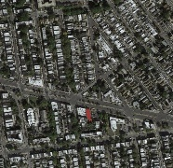 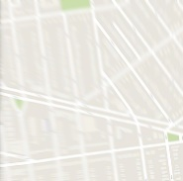 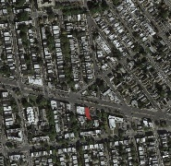

**Discriminator decides whether the target image is real or fake.**

Generator

(UNET)

**Fake input to the discriminator**

Discriminator

(Binary Classifier)

**50/50**

**Real image Real image**

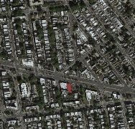

**Real input to the discriminator**

Generator

Loss

GAN Loss

(**Binary Cross Entropy**)

Discriminator

Loss

In pix2pix generator is nothing but a UNET, where it takes a real image and generate a version of fake image. The fake image generated by the generator along with the real image is provided as input to the discriminator.

As you have noticed that the input to the discriminator is a pair of input image and its target image.

As the whole point of discriminator is to discriminate between real and fake images. During training the discriminator, we give half of the real input and half of the fake input to the discriminator, we label real image as 1 and fake image as 0.

We get the discriminator and generator loss and update the discriminator and generator accordingly, apart from the regular GAN loss generator receive one more feedback as L1 loss popularly known as Mean Absolute Error (MAE). MAE error is the difference between the images. generated by the generator and the target image, and L1 loss has 100 more weighed than the GAN loss.